# VISI & MISI BMKPM

VISI

Penjana unggul pelajar bumiputera berkualiti ke institusi pengajian tinggi dalam bidang sains, teknologi dan professional.

MISI

Membangunkan potensi pelajar bumiputera dalam bidang sains, teknologi dan profesional melalui pendidikan prauniversiti yang berkualiti untuk melahirkan modal insan yang cemerlang.

# Objektif Pembelajaran Program (Programme Educational Objectives, PEO)

Programme Educational Objectives (PEO)

Upon a year of graduation from the programme, graduates are:

|  |  |
| --- | --- |
| PEO 1 | Knowledgeable and technically competent in science disciplines study in-line with higher educational institution requirement. |
| PEO 2 | Able to apply information and use data to solve problems in science disciplines. |
| PEO 3 | Able to communicate competently and collaborate effectively in group work to compete in higher education environment. |
| PEO 4 | Able to use basic information technologies and engage in life-long learning to continue the acquisition of new knowledge and skills. |
| PEO 5 | Able to demonstrate leadership skills and practice good values and ethics in managing organisations. |

# Hasil Pembelajaran Program (*Programme Learning Outcomes,* PLO)

Programme Learning Outcomes (PLO)

At the end of the programme, students should be able to:

|  |  |
| --- | --- |
| PLO I | Acquire knowledge of science and mathematics as a fundamental of higher level education. |
| PLO 2 | Apply logical, analytical and critical thinking in scientific studies and problem solving. |
| PLO 3 | Demonstrate manipulative skills in laboratory works. |
| PLO 4 | Collaborate in group work with skills required for higher education. |
| PLO 5 | Deliver ideas, information, problems and solution in verbal and written communication. |
| PLO 6 | Use basic digital technology to seek and analyse data for management of information. |
| PLO 7 | Interpret familiar and uncomplicated numerical data to solve problems. |
| PLO 8 | Demonstrate leadership, autonomy and responsibility in managing organization. |
| PLO 9 | Initiate self-improvement through independent learning. |
| PLO 10 | practice good values attitude, ethics and accountability in STEM and professionalism. |

# Hasil Pembelajaran Kursus (Course Learning Outcome, CLO) dan Pemetaan CLO terhadap PLO

Hasil Pembelajaran Kursus (Course Learning Outcome, CLO)

At the end of the course, students should be able to:

|  |  |
| --- | --- |
| 1. | Describe basic concepts of mechanics, waves, matters, heat and thermodynamics.  (C2, PLO 1, MQF LOC i) |
| 2. | Solve problems related to mechanics, waves, matters, heat and thermodynamics.  (C4, PLO 2, MQF LOC ii) |
| 3. | Apply the appropriate scientific laboratory skills in physics experiments.  (P3, PLO 3, MQF LOC iii a) |

Pemetaan CLO terhadap PLO

|  |  |  |  |  |  |
| --- | --- | --- | --- | --- | --- |
| PEO  PLO | PEO 1 | PEO 2 | PEO 3 | PEO 4 | PEO 5 |
| PLO 1 | √ |  |  |  |  |
| PLO 2 |  | √ |  |  |  |
| PLO 3 | √ |  |  |  |  |
| PLO 4 |  |  | √ |  |  |
| PLO 5 |  |  | √ |  |  |
| PLO 6 |  |  |  | √ |  |
| PLO 7 |  | √ |  |  |  |
| PLO 8 |  |  |  |  | √ |
| PLO 9 |  |  |  | √ |  |
| PLO 10 |  |  |  |  | √ |

# Huraian Sukatan Pelajaran (Curriculum Specifications)

**SP015**

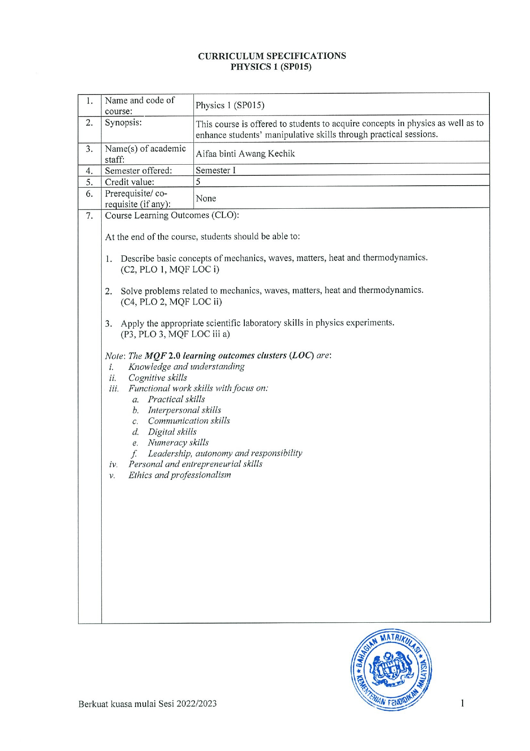

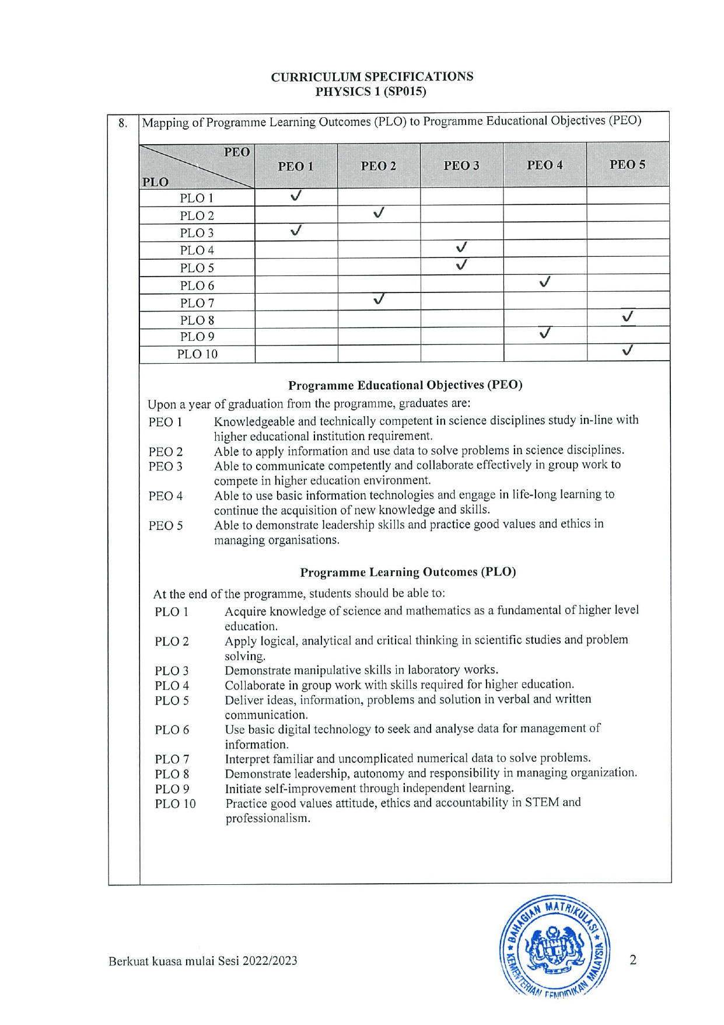

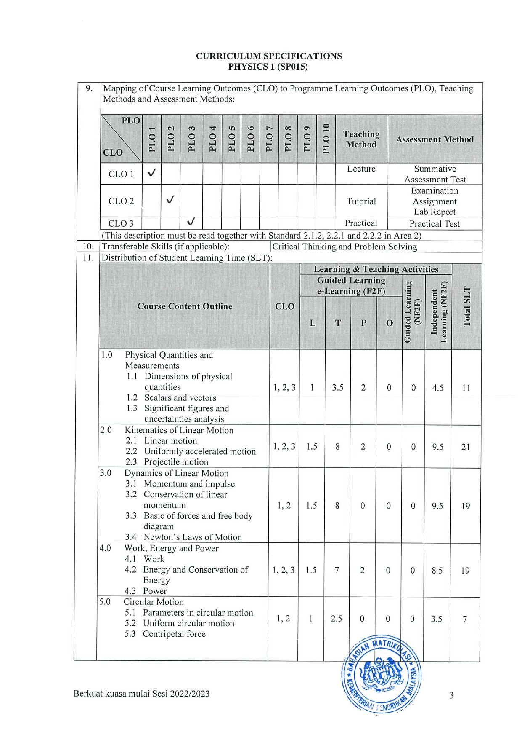

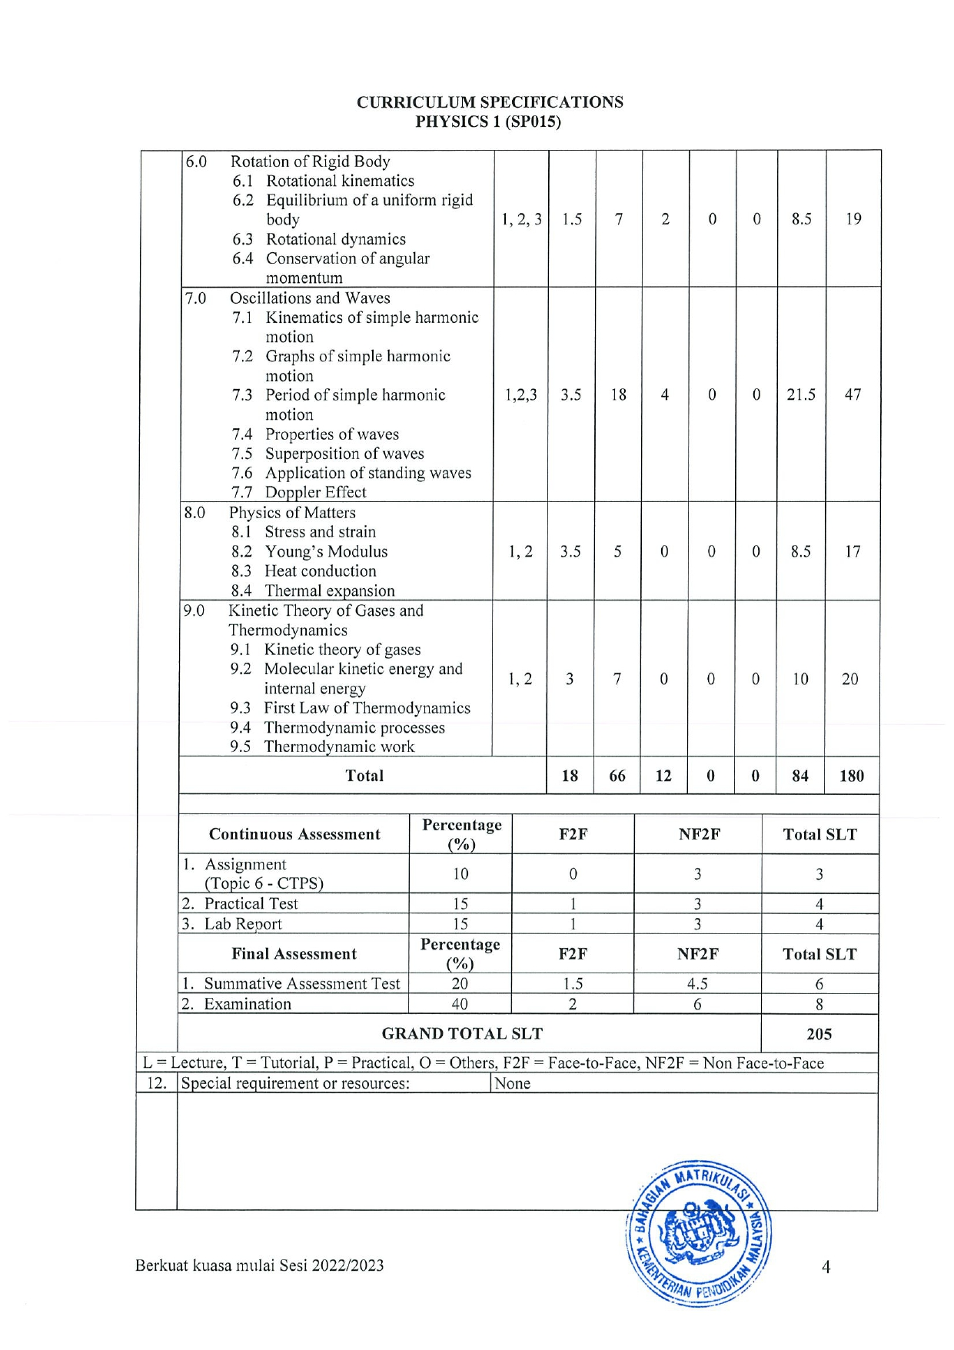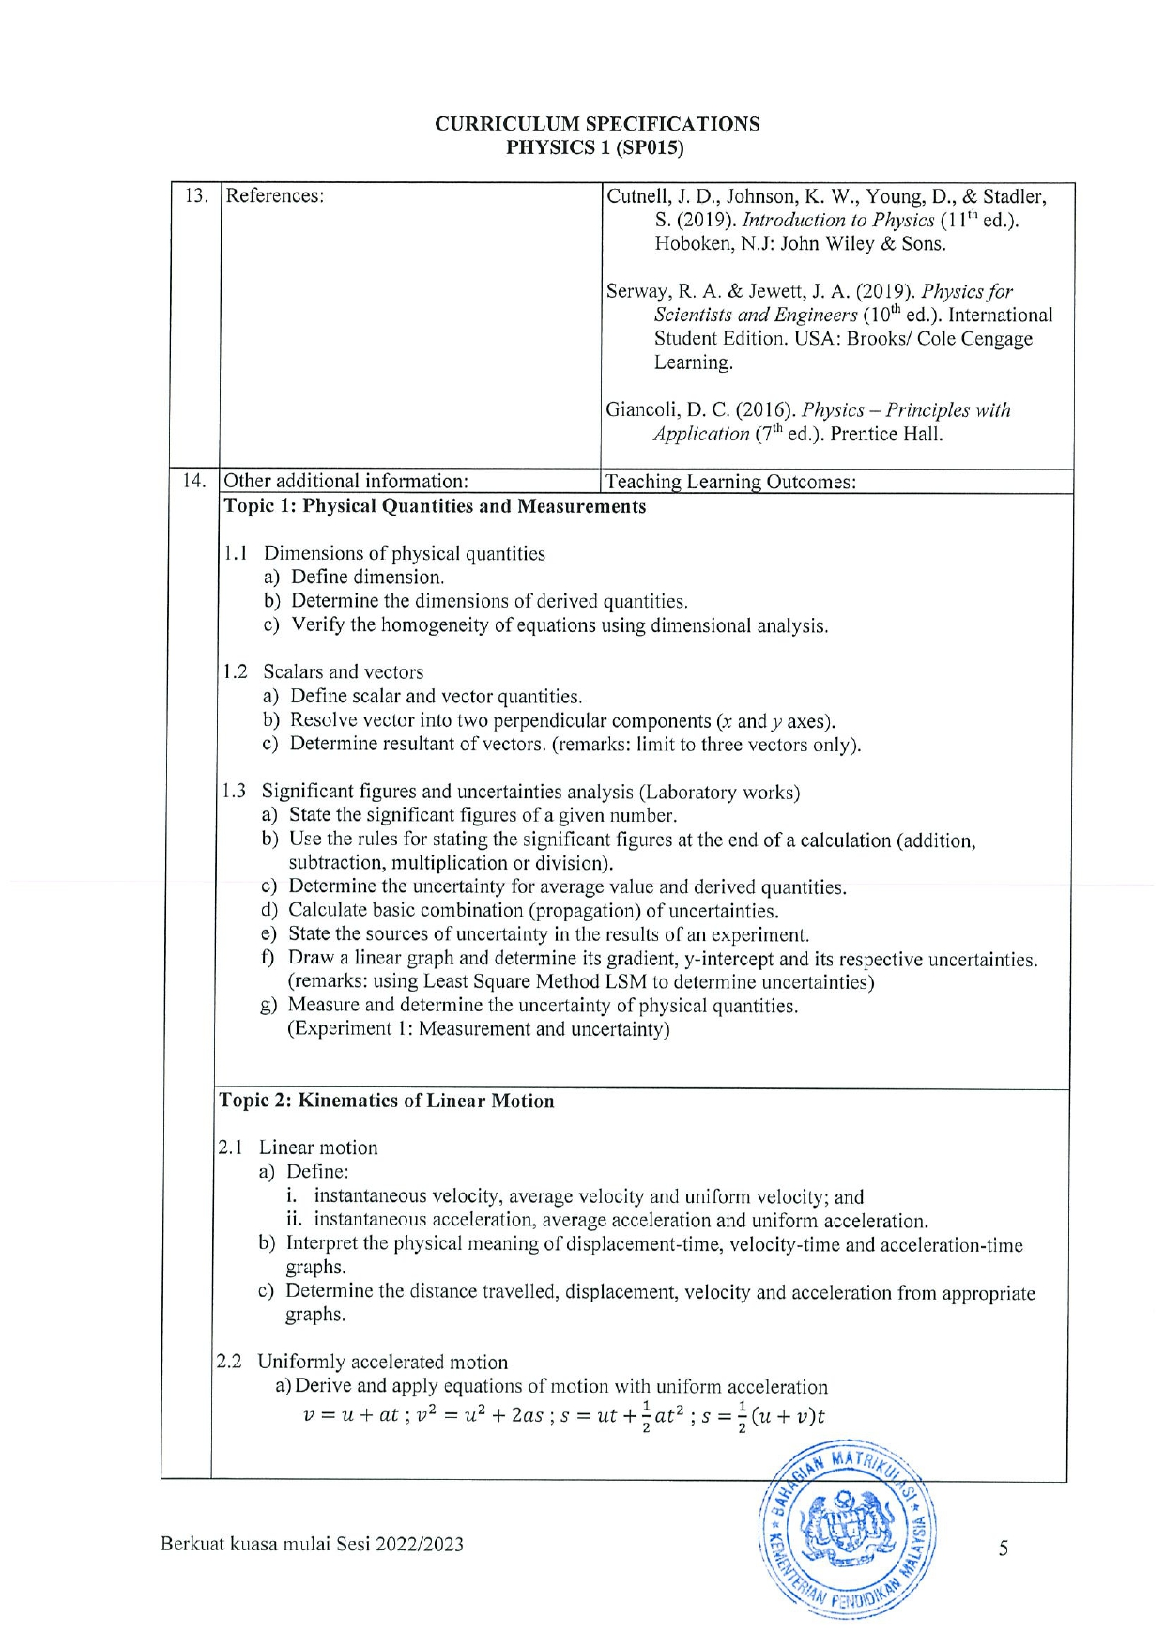

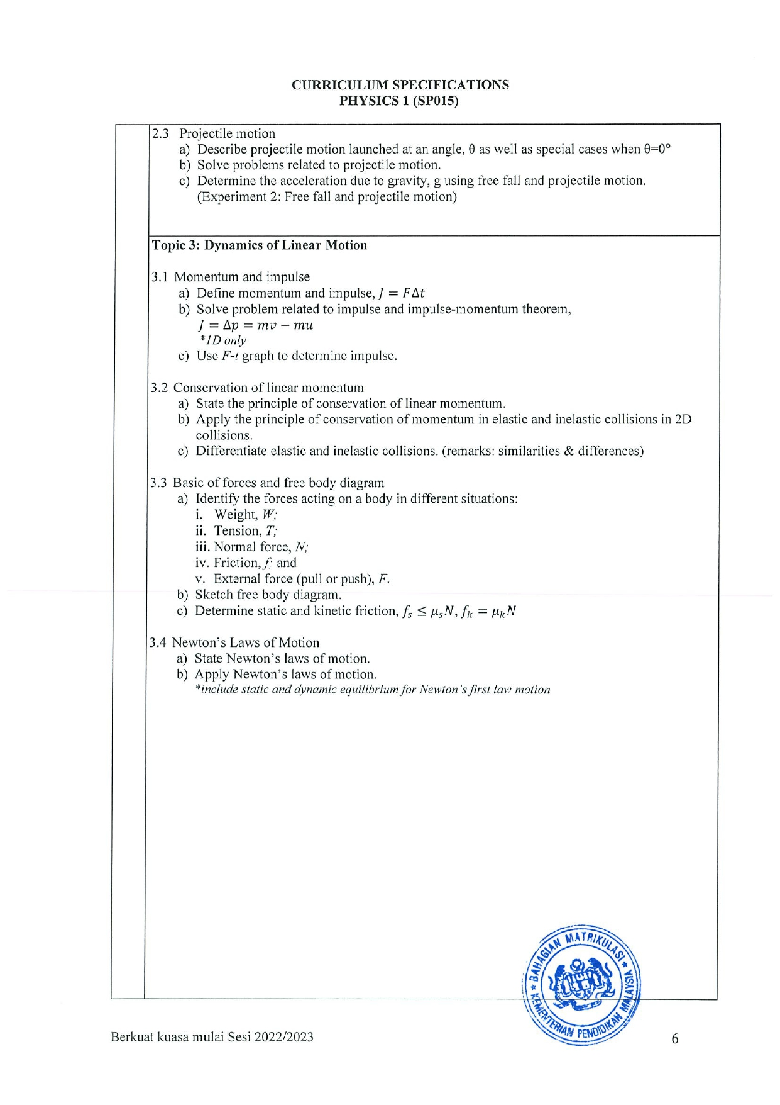

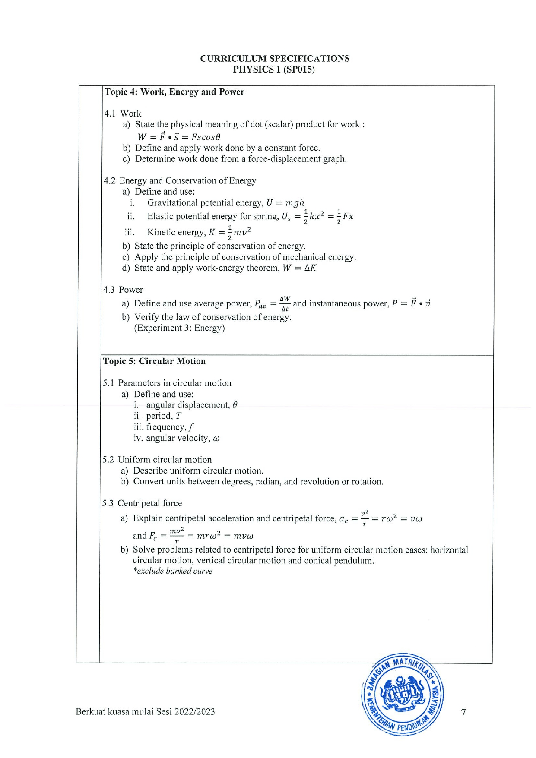

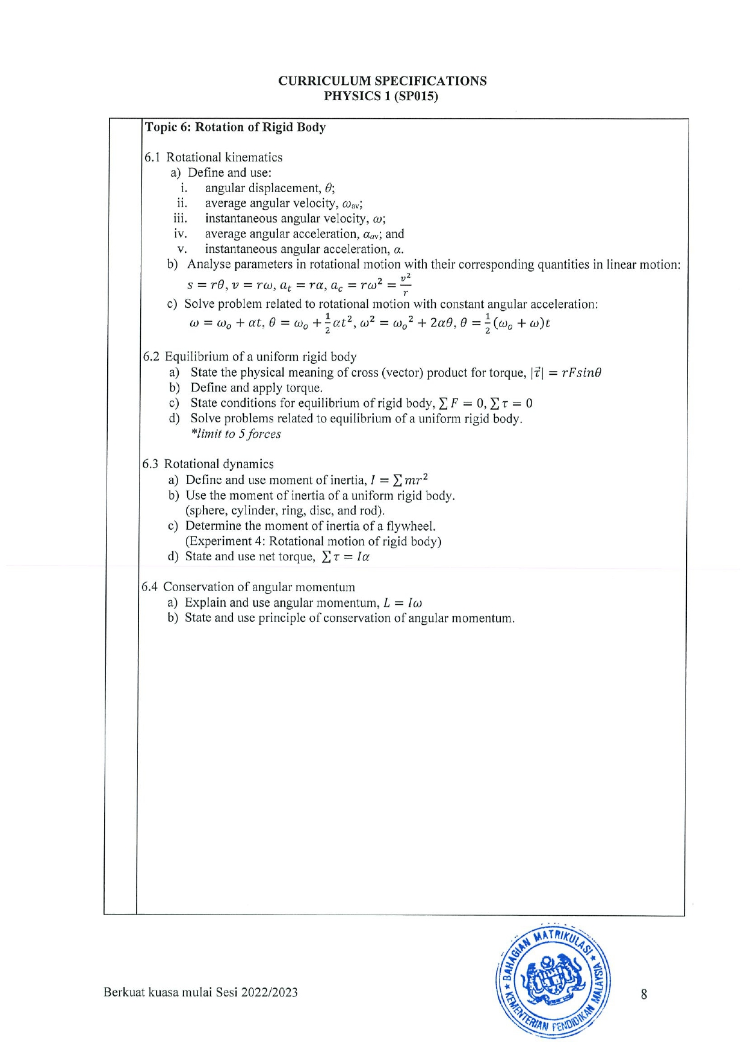

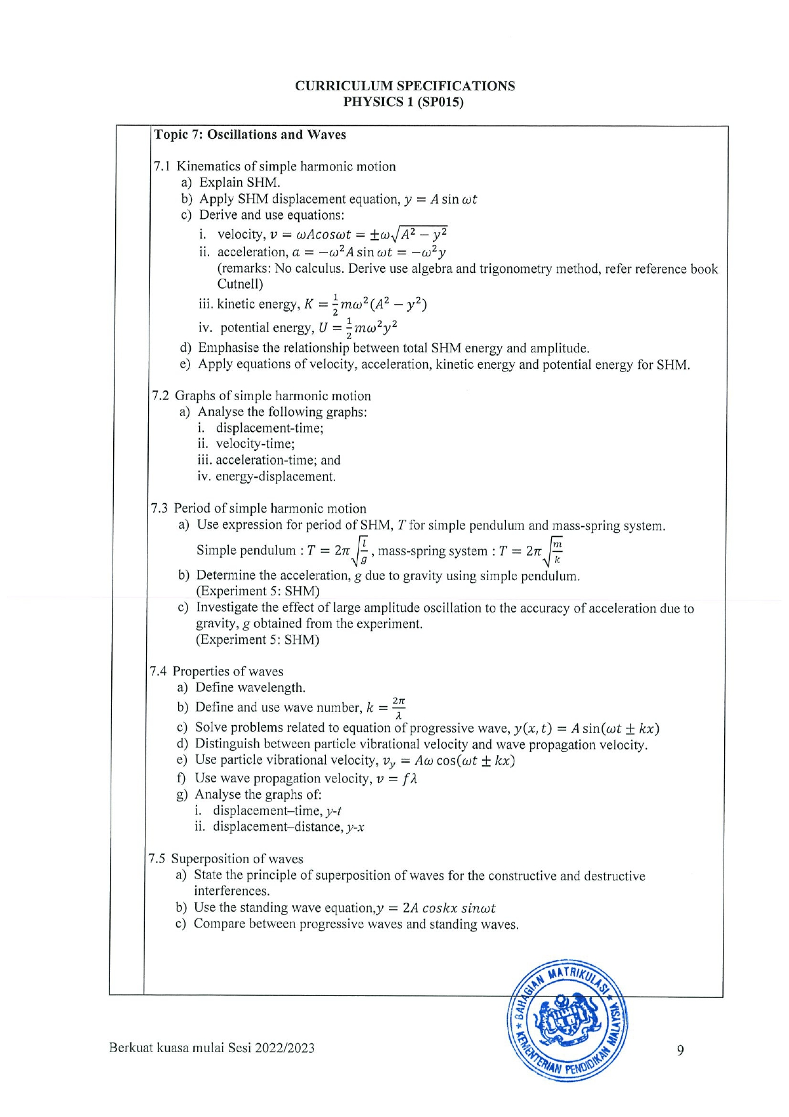

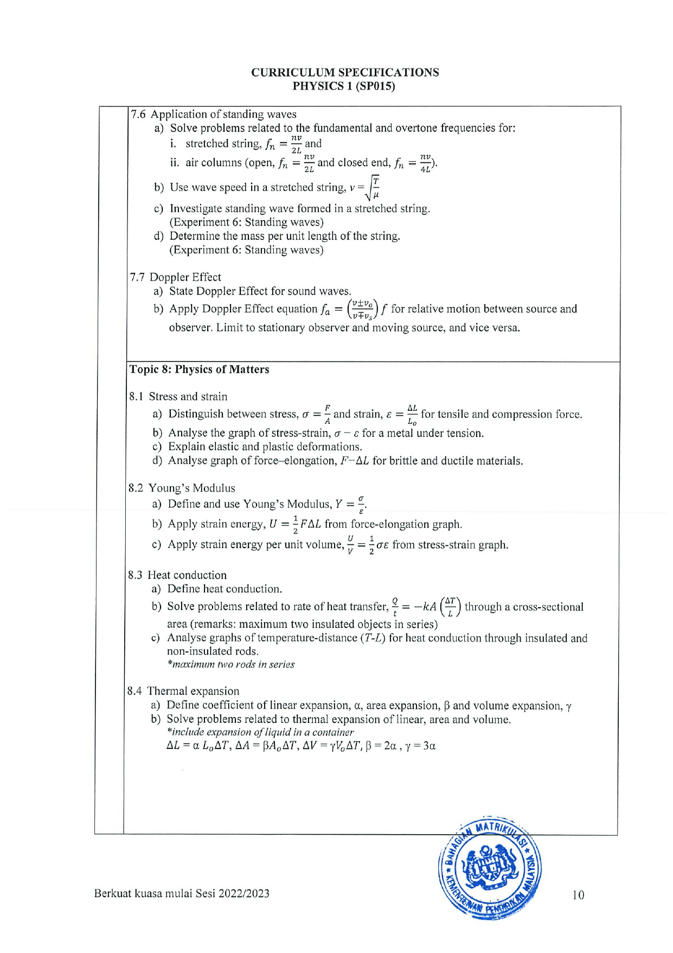

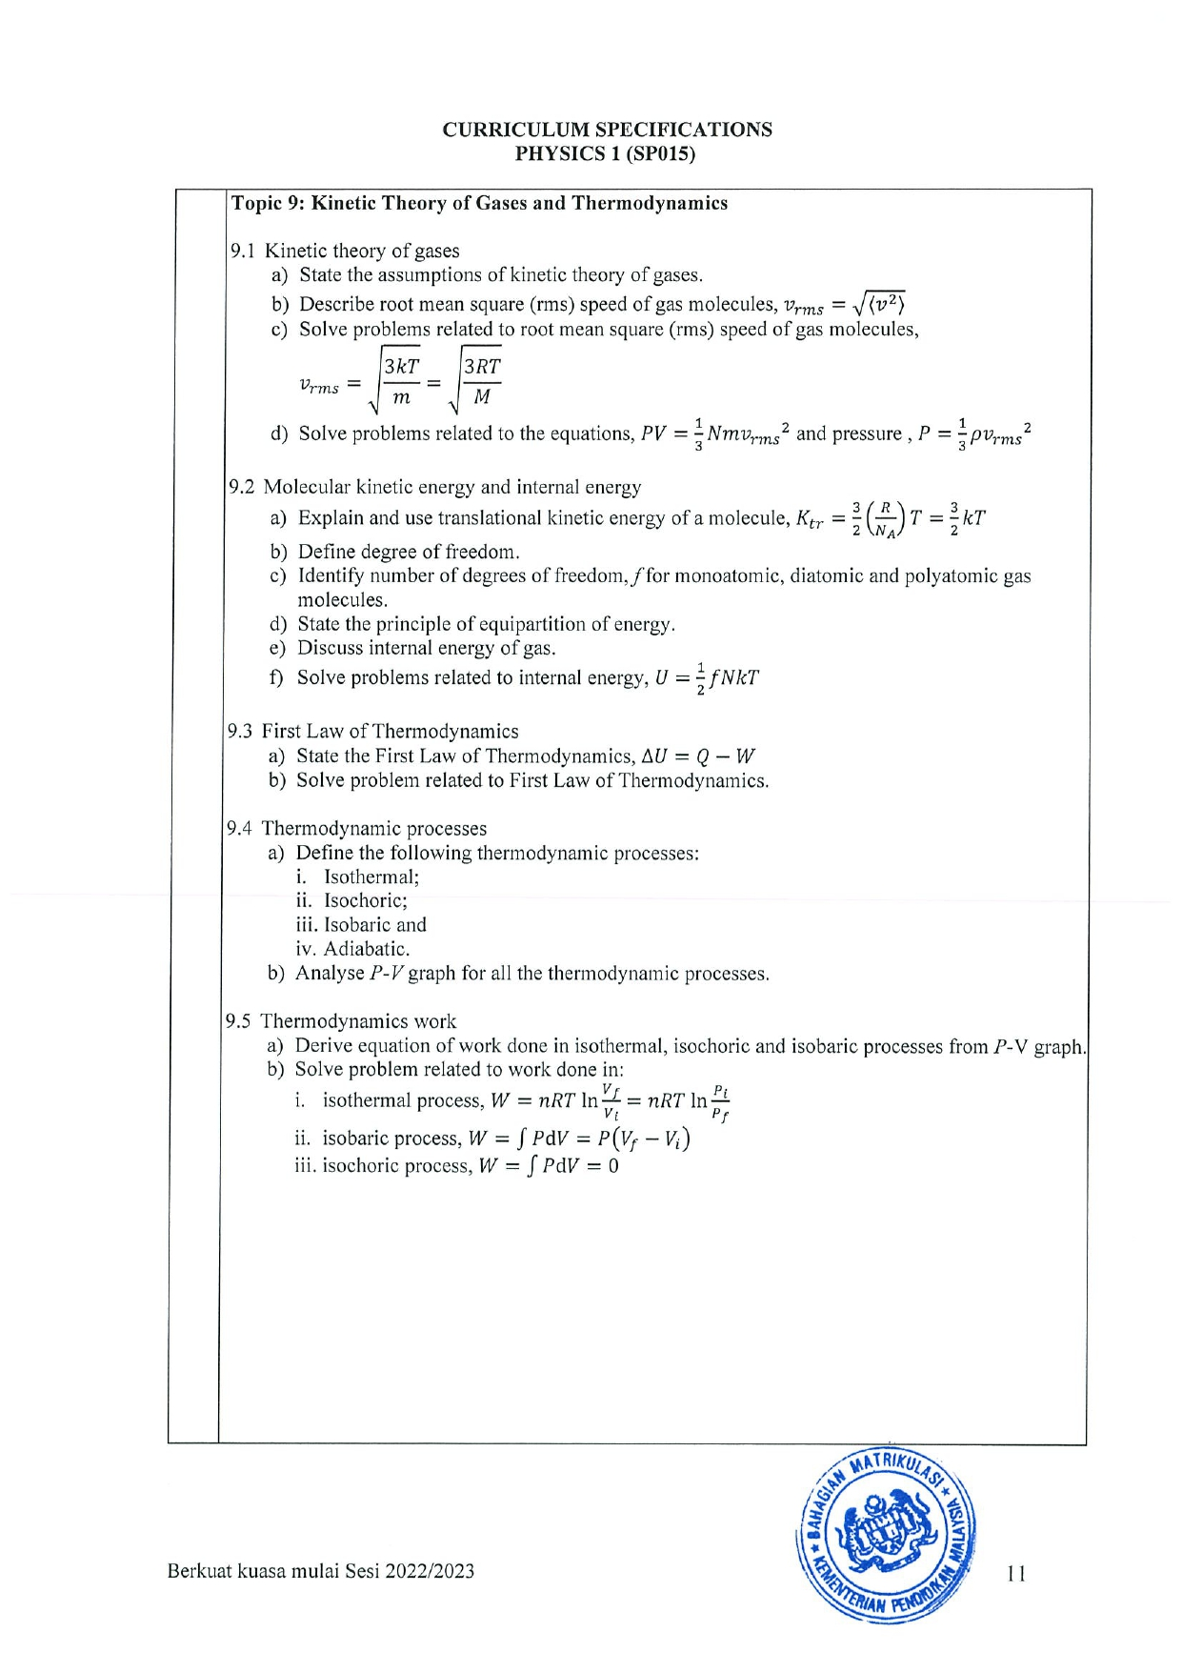

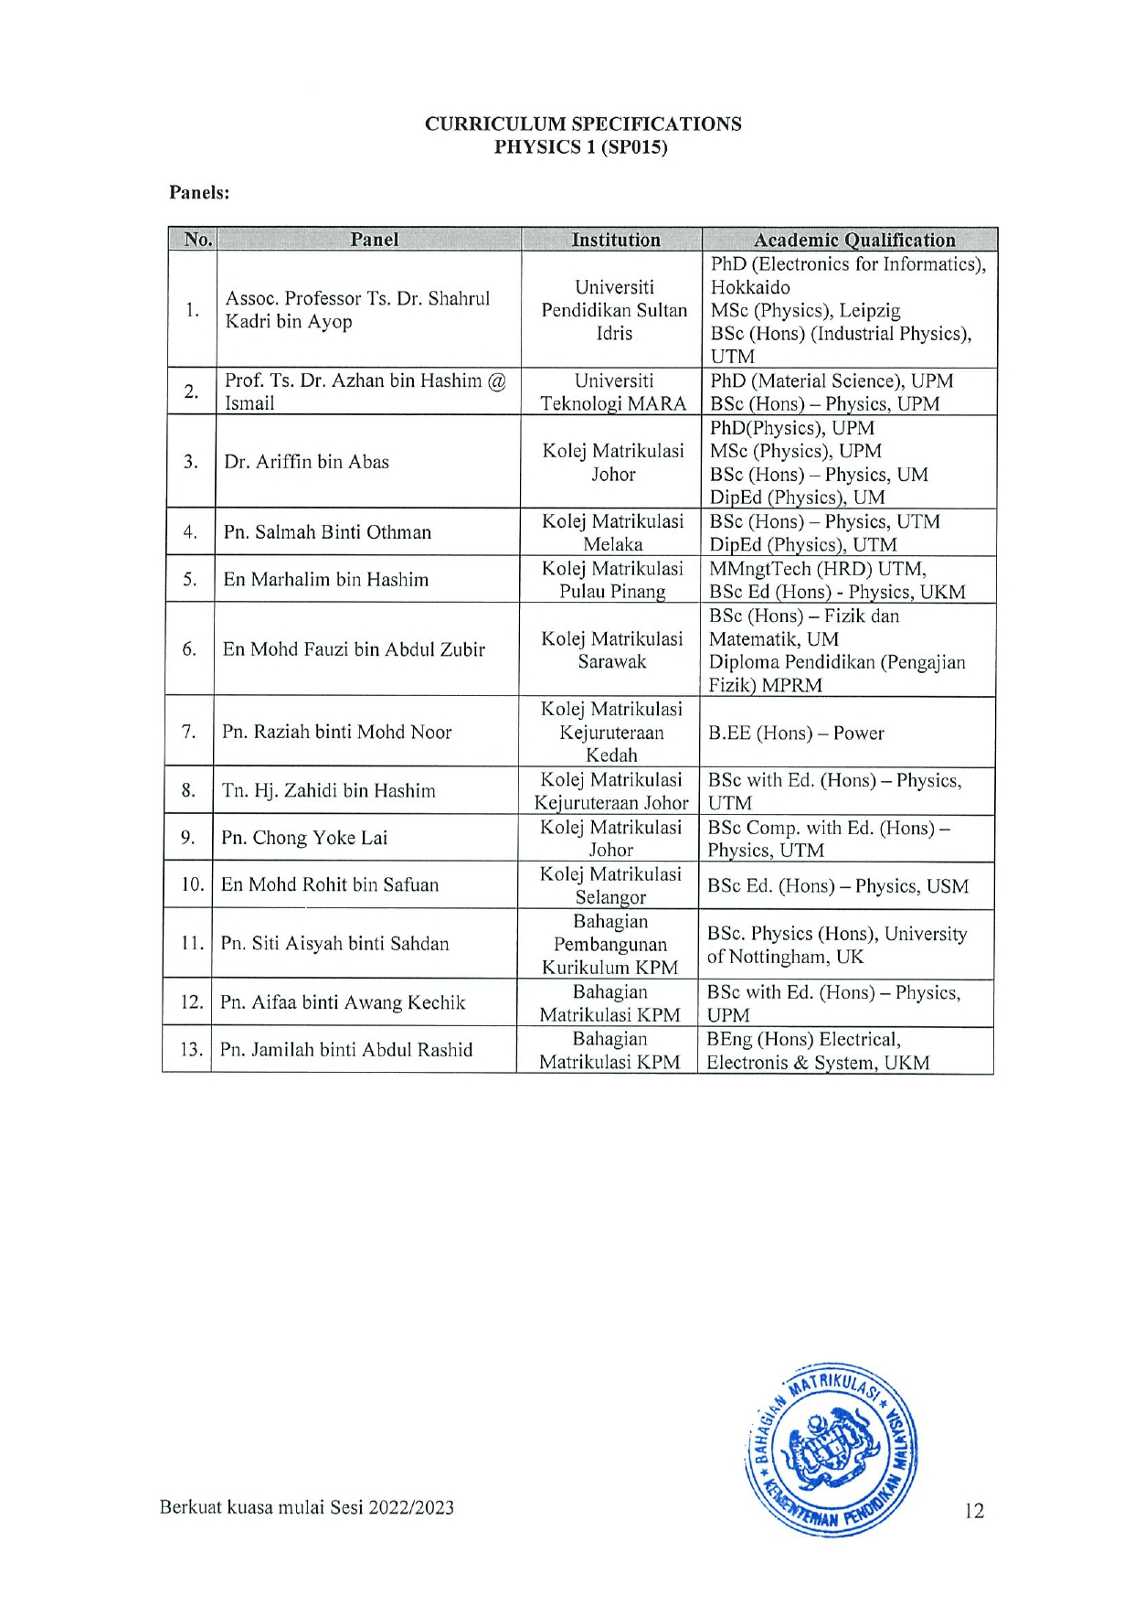

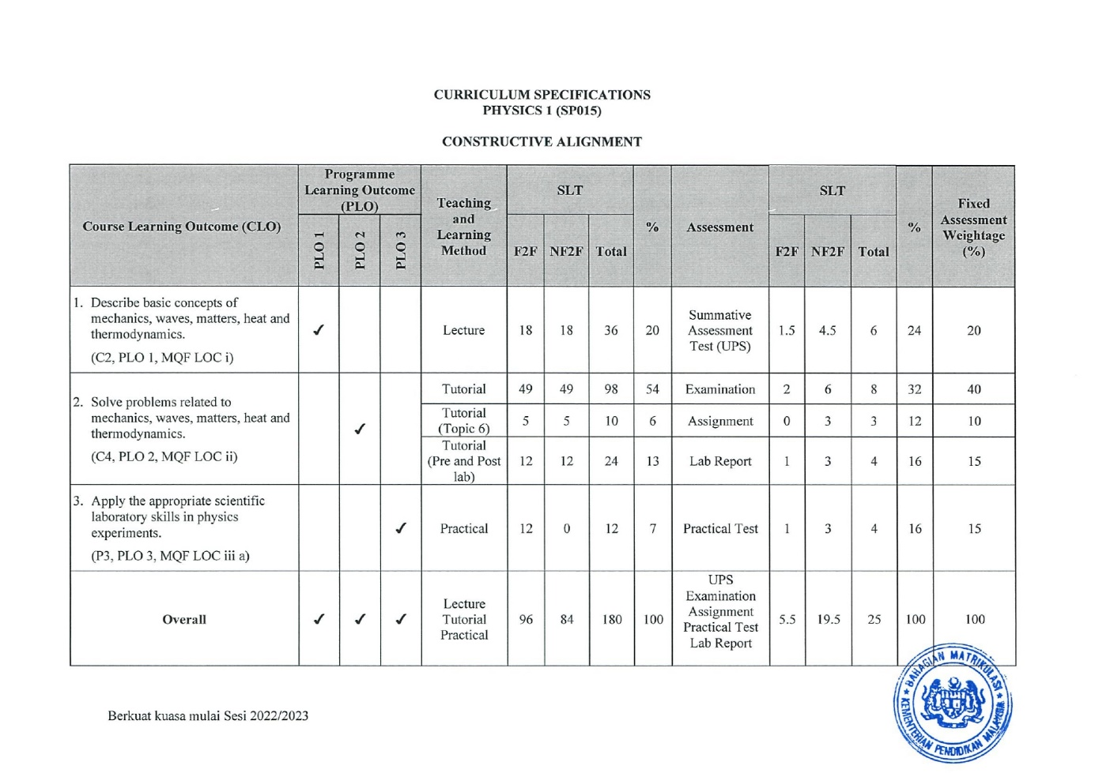

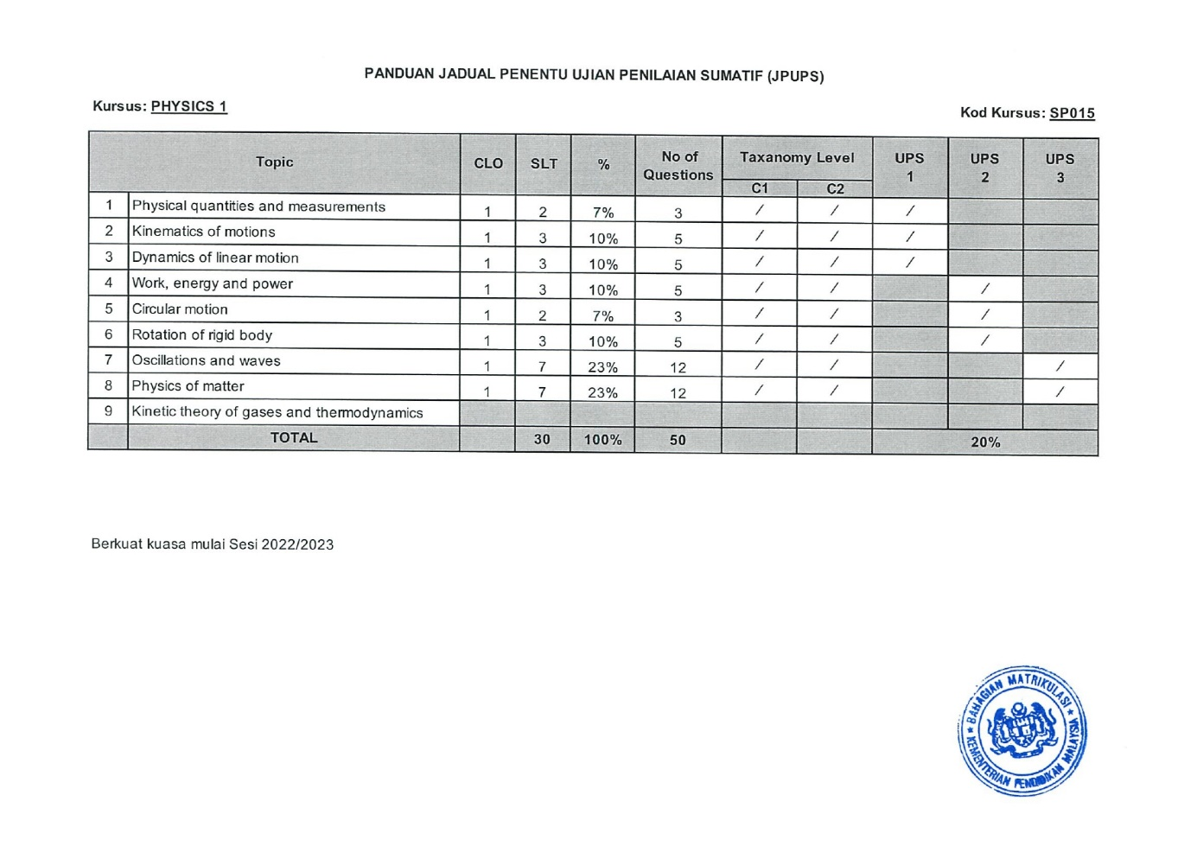

**SP025**

